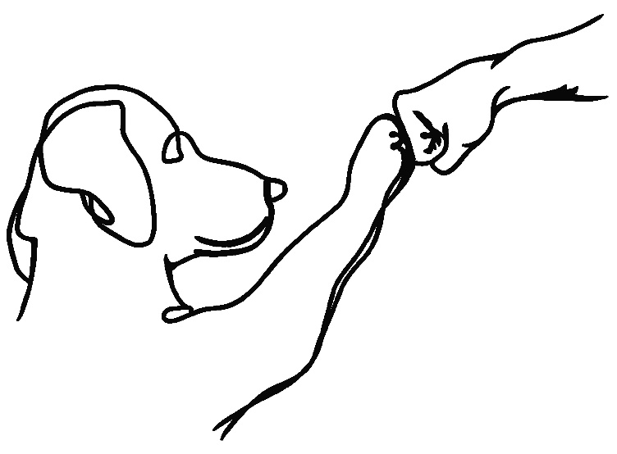
865 RESCUE AND REHOME
FOSTER HANDBOOK
- INTRODUCTION
- SUPPLIES NEEDED
- BEHAVIORAL ISSUES
- HEALTH ISSUES
- RUFF START RESCUE SUPPORT/CONTACT

INTRODUCTION

Fostering a dog or puppy can be an extremely rewarding experience. By providing a foster training and a handbook, a foster home can drastically affect the “adoptability” of the dogs they foster. We will give you information to help you provide the best experience for your foster pup, know what to expect and you will have important contacts and numbers for every situation. Thank you for becoming a 865 Rescue and Rehome foster family, we appreciate you!

SUPPLIES NEEDED

Water/food bowls in appropriate size
Leash
High quality dog or puppy food
Chew toys
Appropriate size crate/kennel
Dog bed, blankets, or towels for comfort
Pee pee pads
Diapers or bands

***Rescue will try to provide as much as we can. We will provide all food! We have a limited supply of kennels, dog beds, pee pee pads, and diaper or bands. We will continue to request donations to supply the needs of the foster dogs.

BEHAVIORAL ISSUES

It is common for a dog to experience some behavioral problems and need a period of adjustment when placed into a new environment. Fosters homes are in a unique position to help increase the “adoptability” of their foster dogs by providing some basic training. The following is a list of common behavioral problems as well as suggestions for behavior modification.

LACK OF HOUSE TRAINING

Chances are your foster dog will need at least a refresher course in house-training. Many rescued dogs have spent most of their lives outside and never learned the rules of living indoors. Other dogs may have once been house-trained, but may still have an accident or two when transitioning into a new home.

The most common element of effective house training is extensive supervision. Correcting a dog for eliminating in the house is only effective if the dog is caught in the act. For this reason, it is essential that the dog be under your supervision at all times. There will, of course, be times when you are unable to watch the dog constantly. During these times you can confine the dog to a crate. The crate should be just large enough for the dog to be able to comfortably stand up, turn around and lie down. Because a dog will try not to soil the area where they sleep, he will usually not urinate or defecate in a crate.

When the dog is allowed out of the crate, they should be taken outside immediately. If the dog eliminates outside, give him lots of praise. If the dog does not eliminate it is important that you supervise the dog closely once you re-enter your home. If you catch the dog having an accident in the house, tell the dog “NO” in a firm (but not angry) voice. Take the dog straight outside and give him a chance to finish eliminating outside. If the dog does eliminate, give lots of praise.

When house-training a dog use common sense. Give the dog a chance to eliminate outside following meals and naps. Pay attention to the dog’s behavioral signals. If you observe the dog circling, sniffing the floor, or moving toward the door, take the dog outside.

HOUSE-TRAINING DON’TS

Do not rub the dog’s nose in it! This method of training has been proven ineffective by trainers and behaviorists. The only message a dog gets from this type of “training” is that you are angry. The dog will likely not learn to eliminate outside and may instead learn to fear you

Do not correct the dog after the fact! Again, this method of training has been proven ineffective. Punishing a dog for something they did much earlier will not yield the results you are looking for. Yes, they will behave submissively and perhaps look guilty, but this is because the dog knows you are angry, not because they know that, earlier they did something wrong.

House-training is not a process that happens overnight. Be patient. Any progress you can make with your foster dog on house-training will make your life easier and help improve the dog’s chances for successful placement.

CHEWING

Destructive chewing is a phase that all puppies go through. It usually starts around three months and can last until the dog is one year old. During this time, the dog’s adult teeth are coming in and chewing helps relieve the pain. Adult dogs may also have problems with chewing, but for different reasons. Adult dogs usually chew on inappropriate things because they are anxious or bored, or because they have never been taught what is appropriate to chew on.

The best solution for destructive chewing is providing your foster dog with something that is acceptable to chew on. Have plenty of chew toys available at all times. If you catch the dog chewing on something inappropriate, tell the dog “NO” in a firm (but not angry) voice, and replace the item with something more appropriate. If the destructive chewing occurs when you are away, consider confining the dog to a crate. A Crate will help keep both the dog and your home safe. It is also important that your foster dog is getting plenty of exercise. A tired dog will sleep and not chew!

SEPARATION ANXIETY

It is pretty common for foster dogs to experience some separation anxiety when left alone. The severity of the anxiety can range from pacing and whining to much more destructive behavior. A dog may experience separation anxiety simply because they have a very dependent personality, or because they are reacting to a history of abuse or abandonment. Whatever the reason, separation anxiety can be difficult to deal with because you are not around when it happens.

The most common sign that a dog may be suffering from separation anxiety is destructive behavior when left alone. A dog may scratch frantically at the door or make other attempts to get out of the house, or the dog may chew on things or engage in other destructive behaviors. If you have reason to suspect that your foster dog is suffering from separation anxiety when you are away, consider confining the dog to a crate. If used appropriately, the crate will help the dog feel safe and secure and hopefully relieve some of the anxiety. And, until the separation anxiety itself can be examined and dealt with, a crate will help keep both your home and your foster dog safe.

If you do have the time to work with your foster dog, there are several things you can try to help alleviate the separation anxiety. Start out by leaving the dog in your home for very short intervals. Tell the dog to wait and then walk outside for a few minutes before returning. When you return to the house, praise the dog for waiting. Begin to gradually leave the dog for longer and longer periods of time. It is important that, when you leave, you remain calm and not make a big deal out of leaving. It is also important that you not be too excited when you return.

SEPARATION ANXIETY CONT…
You want to praise the dog, but calmly. You don’t want your return to be such an exciting event that the dog anxiously anticipates the moment of your return. Perhaps the most effective treatment for separation anxiety is time. Be patient. As your foster dog spends more time with you, they will begin to feel more secure in knowing that when you leave, you always come back.

Some destructive behavior that appears to be related to separation anxiety may, in fact, be the product of boredom. Try providing chew toys and other play items that will entertain your foster dog while you are away. There are several products on the market that work quite well. One of the more popular toys keeps dogs engaged by making them work for food or treats. Once the toy is filled with some kind of small food item, the dog must work by rolling and tipping the toy until a treat falls out. Most of these products allow you to adjust the level of difficulty, and can keep a dog entertained for significant periods of time.

Don’t forget to make sure your foster dog gets plenty of exercise. TA tired dog is much less likely to engage in behaviors associated with anxiety or boredom.

NOTES ON CRATE TRAINING

A crate is a great way to keep both your foster dog and your home safe. If you decide to use a crate, make sure the crate is always a positive place for your foster dog. NEVER USE A CRATE FOR PUNISHMENT. When introducing a dog to a crate, use a happy tone of voice and tell the dog to kennel up or crate. Once the dog has entered the crate, give them lots of praise and

perhaps a treat reward. If you have a difficult time getting the dog to enter the crate or if the dog seems afraid, try leaving the crate door open and placing the dog’s food and water bowls just inside the door. Allow the dog to wander into the crate and eat at their leisure. Once the dog seems comfortable with the crate, you can try confining the dog to the crate for short intervals.

NEVER CONFINE A PUPPY FOR LONGER THAN FOUR HOURS AT A TIME, OR AN ADULT DOG FOR LONGER THAN EIGHT HOURS AT A TIME. Remember, the dog will not want to soil his crate so forcing the dog to stay in the crate longer than he can comfortably “hold it” is inappropriate.

HEALTH ISSUES

Because most foster dogs are rescued from shelter environments, it’s difficult for rescue partners to ensure that they will always be healthy. A dog who appears healthy at the time of rescue could easily begin to show signs of illness several days later. For this reason, it is very important that foster homes keep their own dogs up to date on vaccinations.

COMMON ILLNESSES IN DOGS

The following information is intended to help you better understand and recognize some of the more common illnesses in dogs.

Canine Distemper
Canine Distemper is a viral disease that is often fatal. Distemper is most commonly seen in puppies 3-6 months old. Early signs resemble a severe cold. The vaccine for canine distemper is considered very effective.
Signs & symptoms include, eye congestion and discharge, loss of appetite, vomiting, weight loss, nasal discharge and diarrhea.
Treatment is fluid therapy and antibiotics by veterinarian.
Transmission: VERY CONTAGIOUS (especially to unvaccinated dogs)

RINGWORM
Ringworm is a fungus related to athlete’s foot and not actually a worm.
Signs & symptoms include intense itching and scratching
Treatment: deworming medication
Transmission: contagious to other dogs and cats but only through contact with feces

FLEAS
Fleas are tiny insects that feed on the blood of dogs, cats, humans and other animals. Although each flea only consumes a small drop of blood, fleas usually attack in large numbers.
Signs & symptoms include intense itching and scratching
Treatment: topical treatment
Transmission: very contagious to other dogs, cats and humans

Round, Tape and Hook Worms
Worms affect a dog’s digestive system. They are most commonly seen in puppies and young dogs.
Signs & Symptoms include large belly, diarrhea and inability to gain weight
Treatment deworming medication by veterinarian prescription
Transmission: contagious to other dogs and cats but only through contact with feces

CLEANING PROCEDURES

It is important that all items and areas used by a sick foster animal be cleaned thoroughly. You can use a 10% bleach solution to reliably kill most viruses and bacteria. Items to be cleaned should be thoroughly wetted with the bleach solution and allowed to stand for several minutes before rinsing. Foster homes that have recently fostered a dog or puppy with parvo or another extremely contagious disease may be asked to wait several months before fostering another unvaccinated dog or puppy.
ROUTINE VETERINARY CARE

Each foster dog will be vetted with routine veterinary care prior to placement in foster care and/or adoption homes. The following schedule outlines the various types of routine care provided.
- Distemper combo vaccine
- Rabies vaccine
- Bordetella vaccine
- De-worm
- Spay/Nueter

SUPPORT

To help ensure the health and safety of your foster dog, the rescue asks that you adhere to the guidelines set forth, including the following:
- Always keep a properly fitted collar on your foster dog at all times
- Keep your foster dog under your control at all times, going outside only on a leash or into a securely fenced area of your home. (foster dogs are not allowed to go to dog parks)
- Let Ruff Start Rescue know if you are no longer able to care for your foster dog. Do not give your foster dog to another person or agency, or board your foster without permission.

CONTACT NUMBERS:

Please contact one of our board and or staff members before taking your foster pet to a vet for any reason. We will provide emergency animal care center phone numbers and locations, but stress that you call 865 Rescue and Rehome first to advise us.

865 Rescue and Rehome 865-309-5117

Director: Susanne Gregg 865-621-5800

